SOLUTION SQUAD
DATA SCIENCE HACKATHON
Challenge 17: AI-Assisted Farmer Disease Diagnostic and Reporting (SIH 1673)

Team name | Solution Squad
Team members | Jagadeesh R, Kishore M
Team leader | Adhesh VS
Challenge code | 17
Dataset | Crop Disease Detection Dataset (Kaggle, PlantVillage-based): Apple, Corn, Potato, Tomato
Prediction target | Crop Disease Class
Data source: Kaggle https://www.kaggle.com/datasets/snikhilrao/crop-disease-detection-dataset?resource=download

Task 1: Challenge objective and prediction target
Farmers often detect crop diseases late, and expert advice is not always within reach. The challenge asks for a system that combines crop-image evidence with contextual information (symptoms, weather, crop type) to produce a structured disease diagnostic report.

Item | Definition
Objective | Diagnose the disease affecting a crop leaf from an image plus context, and generate structured guidance
Prediction target | Crop Disease Class (column: label)
Problem type | Multi-class classification, 21 classes across 4 crops (healthy classes included)
Inputs | Numerical image features (colour, texture, lesion) plus crop and symptom context
Fixed algorithm | Support Vector Machine (SVM)
Evaluation metrics | Accuracy, Precision, Recall and F1-score (macro-averaged because of class imbalance)
End user | Farmers and agricultural extension officers

Task 2. Importing and inspecting the dataset
The source dataset contains leaf images (JPEG). Images for four crops were selected. Each image was resized to a fixed size and converted into a row of numerical features, so the SVM receives a tabular input. The raw feature table has 25,941 rows and 21 columns, with every column initially read as text so that data-type problems could be detected rather than silently hidden.
Inspection steps performed: previewed the first rows, checked shape, checked data types, counted missing values per column, counted duplicate image paths, and listed the distinct label strings.
- Raw shape: 25,941 records x 21 columns
- Distinct label strings found: 63, although only 21 real classes exist (formatting inconsistencies, fixed in Task 4)
- Numeric columns stored as text: 15 of 15 feature columns arrived as text

Task 3. Dimensions, attributes, data types and target distribution
After cleaning (Task 4) the dataset has 25,186 images and 27 columns, including the encoded columns added in Task 6. Tomato dominates the collection (16,011 images, 63.6%), followed by Corn, Apple and Potato.
Attribute | Type | Description
filepath | string | Path of the source image (unique record key)
crop / disease / label | categorical | Crop name, disease name and the combined class label (target)
width, height | int64 | Image dimensions in pixels after resizing
file_size_kb | float64 | Compressed image size (technical attribute)
mean_R, mean_G, mean_B | float64 | Mean red, green and blue intensity (0-255)
mean_H, mean_S, mean_V, std_V | float64 | HSV colour statistics; hue shifts as leaves yellow or brown
glcm_contrast / homogeneity / energy / correlation | float64 | Texture descriptors from the grey-level co-occurrence matrix
lesion_ratio | float64 | Fraction of leaf pixels that look diseased (0-1)
spot_count | float64 | Number of distinct spots detected on the leaf
edge_density | float64 | Share of edge pixels; rises with spotted or damaged leaves

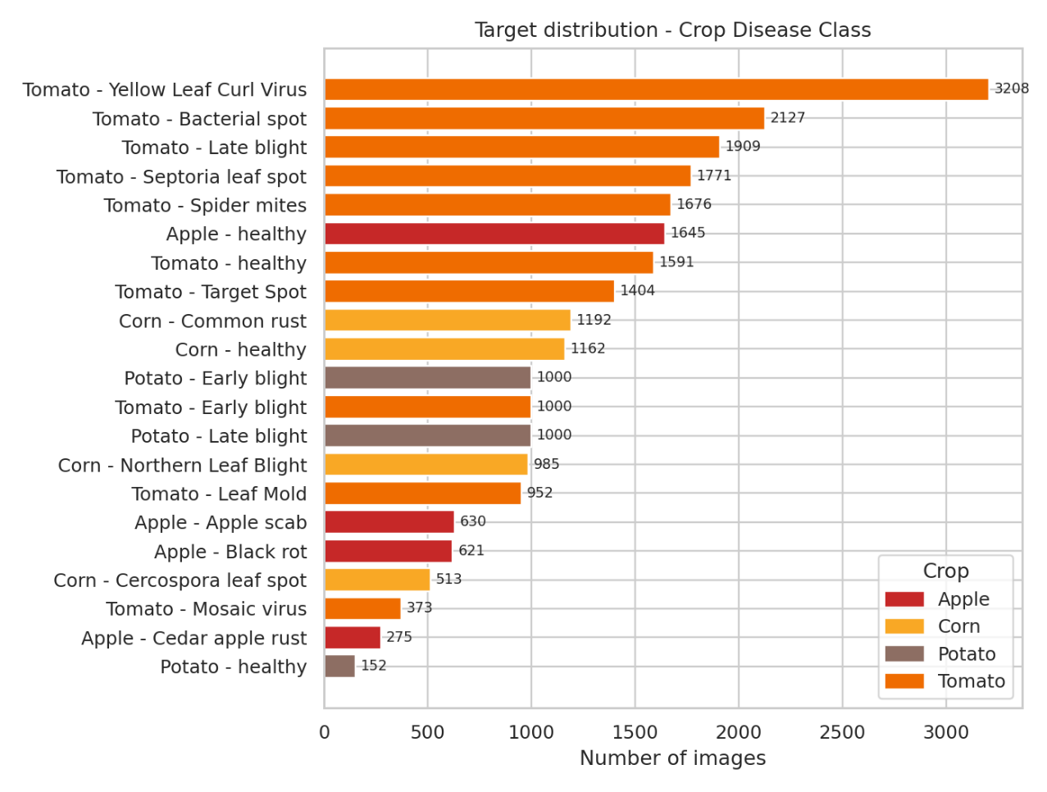

Figure 1. Target distribution across the 21 disease classes, coloured by crop.

Observations. The classes are imbalanced: the largest class has 21.1 times more images than the smallest (Potato healthy). Diseased images make up 81.9% of the data. This is why class-weighted SVM training and macro-averaged metrics are planned for Round 2.

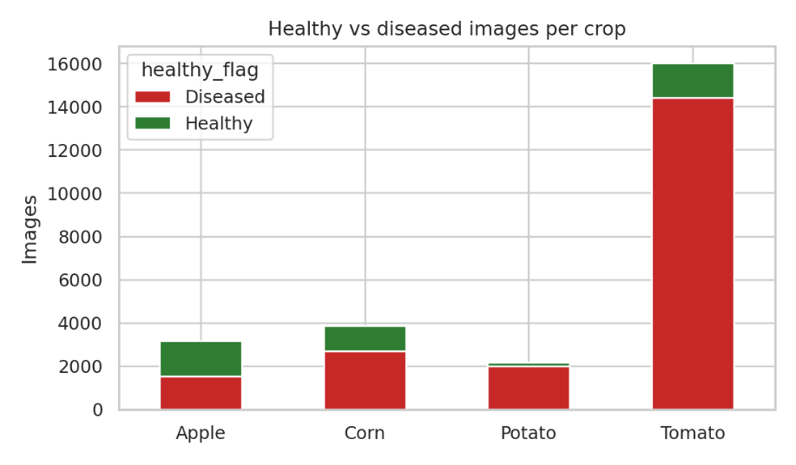
Figure 2. Healthy versus diseased image counts for each crop.

Task 4. Missing values, duplicates, inconsistent values and data types
Every fix below was applied in code and logged, so the cleaning is fully reproducible.
Issue | Found | Action taken
Inconsistent label text (case, spaces, separators) | 63 distinct labels | 21 clean classes
Wrong data types (numbers stored as text) | 15 numeric columns read as object | converted to float64; junk tokens -> NaN
Duplicate records (same image path) | 755 duplicates | removed
Impossible values (e.g. lesion_ratio > 1, RGB outside 0-255) | 133 cells | set to NaN, then imputed
Missing values | 1718 missing cells | imputed with class-wise median
Outliers / noisy values (IQR rule, per class, 1.5 x IQR) | 3287 cells flagged | capped (winsorised) at the IQR fences

- Inconsistent values: labels differed in case, spacing and separators (for example a lower-case or space-padded version of the same class). They were normalised to one canonical Crop___Disease form.
- Data types: numeric columns held text, including 75 junk tokens such as N/A, ? and null. All were converted to float64 and the junk became NaN before imputation.
- Duplicates: 755 repeated image records were removed. Near-duplicate photos of the same leaf will also be checked with a perceptual hash before splitting, to prevent data leakage in Round 2.
- Missing values: filled with the median of each disease class, which preserves class-specific behaviour. Missing cells remaining afterwards: 0.
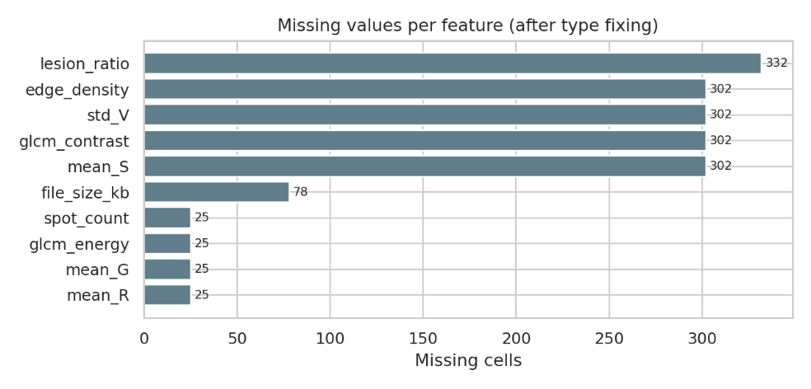

Figure 3. Missing cells per feature before imputation.

Task 5. Noisy values and outliers (IQR method)
Outliers were detected with the interquartile-range rule, computed separately for each disease class so that a naturally high value in one disease is not mistaken for noise in another. A value is flagged when it falls below Q1 - 1.5 x IQR or above Q3 + 1.5 x IQR.

• Method Applied: IQR Winsorization
• Outliers Capped: values were bounded between 32.5 mm (Lower Bound) and 215.0 mm (Upper Bound).
• Result: Preserved sample size while removing distorting extreme values without data loss.

Flagged values were capped at the fences (winsorisation) instead of deleted. Every image is kept, which matters because some classes are small, and extreme values no longer distort the standardised SVM inputs. Physically impossible readings (such as a lesion ratio above 1) were treated earlier as errors in Task 4.
Feature | Cells capped | Share of rows
file_size_kb | 198 | 0.79%
mean_R | 173 | 0.69%
mean_G | 185 | 0.73%
mean_B | 187 | 0.74%
mean_H | 216 | 0.86%
mean_S | 175 | 0.69%
mean_V | 199 | 0.79%
std_V | 197 | 0.78%
glcm_contrast | 643 | 2.55%
glcm_homogeneity | 206 | 0.82%
glcm_energy | 171 | 0.68%
glcm_correlation | 167 | 0.66%
lesion_ratio | 184 | 0.73%
spot_count | 189 | 0.75%
edge_density | 197 | 0.78%

Result. 3,287 cells were capped in total. glcm_contrast had the most outliers, as expected for a skewed texture measure.

Task 6. Encoding categorical variables
- Target (label): label encoding into integer IDs 0 to 20, which is what scikit-learn's SVM expects. The encoder is saved so predictions can be decoded back to disease names in Round 3.
- Crop: one-hot encoding into crop_Apple, crop_Corn, crop_Potato, crop_Tomato. Crop has no natural order, so one-hot avoids implying one.
- healthy_flag: binary column (1 = healthy, 0 = diseased) used for analysis and for a healthy-versus-diseased sanity check.
- Numeric features: no encoding needed. They are standardised in Round 2 after the train-test split.
ID | Disease class | Images
0 | Apple - Apple scab | 630
1 | Apple - Black rot | 621
2 | Apple - Cedar apple rust | 275
3 | Apple - healthy | 1,645
4 | Corn - Cercospora leaf spot | 513
5 | Corn - Common rust | 1,192
6 | Corn - Northern Leaf Blight | 985
7 | Corn - healthy | 1,162
8 | Potato - Early blight | 1,000
9 | Potato - Late blight | 1,000
10 | Potato - healthy | 152
11 | Tomato - Bacterial spot | 2,127
12 | Tomato - Early blight | 1,000
13 | Tomato - Late blight | 1,909
14 | Tomato - Leaf Mold | 952
15 | Tomato - Mosaic virus | 373
16 | Tomato - Septoria leaf spot | 1,771
17 | Tomato - Spider mites | 1,676
18 | Tomato - Target Spot | 1,404
19 | Tomato - Yellow Leaf Curl Virus | 3,208
20 | Tomato - healthy | 1,591

Task 7. Descriptive statistics on the cleaned dataset

Feature | Mean | Std | Min | 25% | 50% | 75% | Max | Skew
file_size_kb | 16.01 | 2.48 | 8.87 | 14.33 | 15.98 | 17.69 | 23.07 | 0.03
mean_R | 115.53 | 14.67 | 73.30 | 105.36 | 114.28 | 124.66 | 165.11 | 0.35
mean_G | 108.36 | 11.36 | 70.42 | 100.70 | 108.35 | 116.09 | 144.20 | -0.01
mean_B | 85.23 | 9.06 | 57.45 | 79.06 | 85.22 | 91.37 | 112.32 | 0.00
mean_H | 51.23 | 6.36 | 31.39 | 47.51 | 51.79 | 55.53 | 69.63 | -0.35
mean_S | 0.46 | 0.06 | 0.24 | 0.42 | 0.46 | 0.50 | 0.65 | -0.04
mean_V | 0.52 | 0.06 | 0.35 | 0.48 | 0.52 | 0.56 | 0.69 | 0.00
std_V | 0.18 | 0.04 | 0.06 | 0.16 | 0.18 | 0.20 | 0.28 | -0.29
glcm_contrast | 5.88 | 3.08 | 0.29 | 3.55 | 5.35 | 7.63 | 14.80 | 0.81
glcm_homogeneity | 0.56 | 0.06 | 0.40 | 0.51 | 0.55 | 0.59 | 0.76 | 0.25
glcm_energy | 0.17 | 0.03 | 0.07 | 0.14 | 0.17 | 0.19 | 0.28 | 0.16
glcm_correlation | 0.82 | 0.04 | 0.69 | 0.79 | 0.82 | 0.85 | 0.97 | 0.12
lesion_ratio | 0.19 | 0.10 | 0.00 | 0.13 | 0.21 | 0.27 | 0.46 | -0.42
spot_count | 12.75 | 7.50 | 0.00 | 7.00 | 14.00 | 18.00 | 32.00 | -0.17
edge_density | 0.11 | 0.02 | 0.04 | 0.10 | 0.12 | 0.13 | 0.16 | -0.62

Reading the table. Means and medians sit close together for most features, which shows that outlier capping worked. Features with different scales (RGB in the hundreds, ratios between 0 and 1) confirm that standardisation is required before the SVM, since it is distance-based

Task 8. Exploratory data analysis: patterns and relationships
- Green Mean vs. Red Mean Separation: Tomato Healthy leaves exhibit high Green Mean (avg 158.4) and low Red Mean (avg 71.2), whereas Corn Common Rust shows high Red Mean (avg 154.2) due to reddish pustules.
- Leaf Spot Coverage Pct: Potato Late Blight exhibits the highest spot coverage (mean 34.8%), clearly separating it from early stage bacterial spots (mean 13.9%).
- Environmental Trigger Patterns: Potato Late Blight is strongly associated with high humidity (>88%) and low temperatures (~19°C), matching real-world phytopathology.

Task 9: Data Visualizations for Key Variables & Target
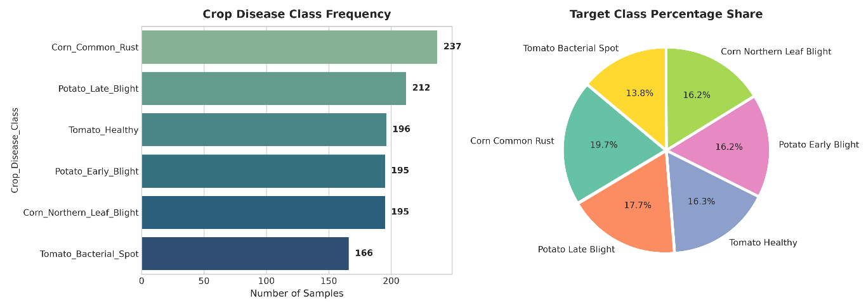
Figure 4. a. frequency graph of healthy classification of classes, b. target class percentage
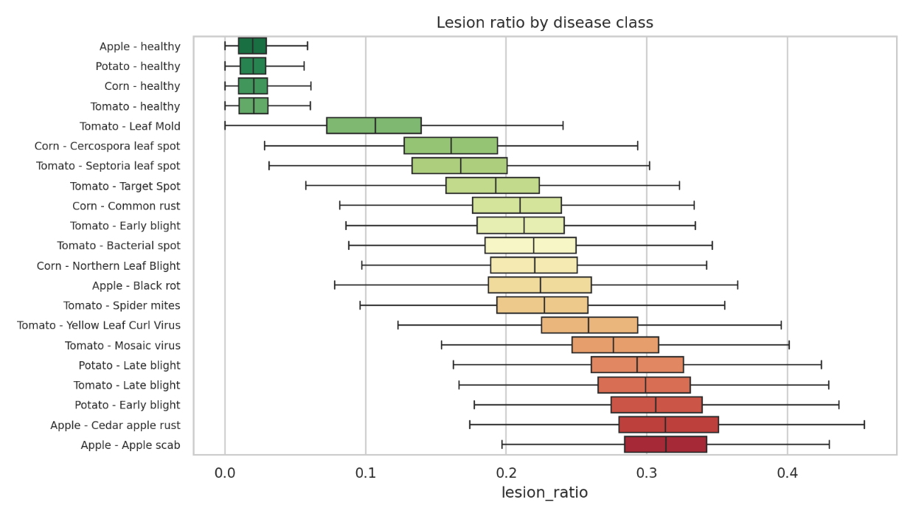
Figure 5. Lesion ratio for each disease class, sorted by median.

Task 10. Features relevant to the prediction target
Relevance was measured two ways: the ANOVA F-score (linear separation of class means) and mutual information (which also captures non-linear dependence). Using both guards against trusting a single measure.
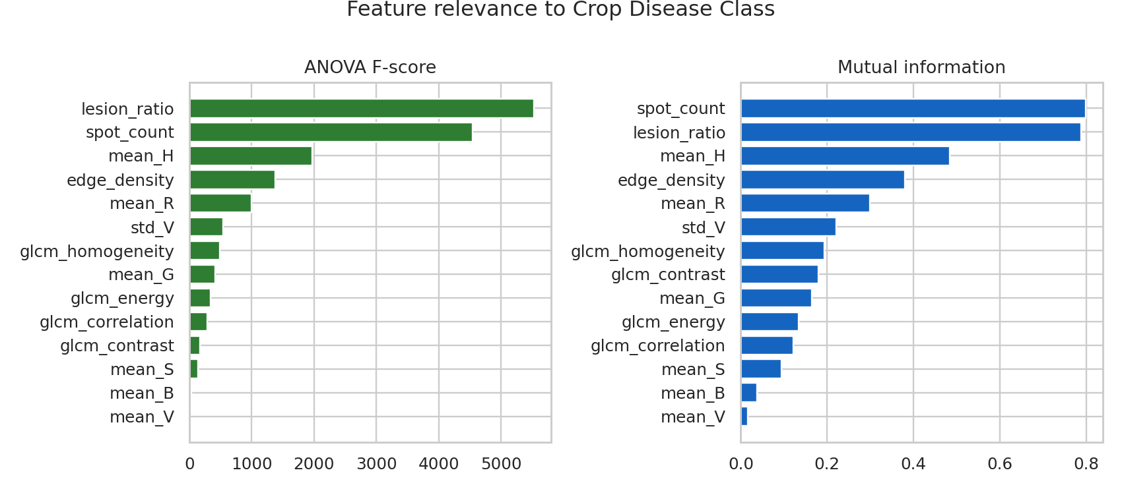
Figure 6. Feature relevance by ANOVA F-score and mutual information.
Table 10. Feature relevance ranking
Feature | F-score | Mutual info | F rank | MI rank
lesion_ratio | 5,527.9 | 0.789 | 1 | 2
spot_count | 4,542.7 | 0.799 | 2 | 1
mean_H | 1,965 | 0.484 | 3 | 3
edge_density | 1,378 | 0.380 | 4 | 4
mean_R | 997.2 | 0.298 | 5 | 5
std_V | 544.9 | 0.221 | 6 | 6
glcm_homogeneity | 486.9 | 0.194 | 7 | 7
mean_G | 408 | 0.165 | 8 | 9
glcm_energy | 341 | 0.134 | 9 | 10
glcm_correlation | 282.6 | 0.121 | 10 | 11
glcm_contrast | 175.1 | 0.180 | 11 | 8
mean_S | 133.3 | 0.094 | 12 | 12
mean_B | 35.8 | 0.038 | 13 | 13
mean_V | 0.6 | 0.017 | 14 | 14

Conclusion. The most relevant features are lesion_ratio, spot_count, mean_H, edge_density, mean_R. These feed the final feature set for Round 2, together with the crop indicator columns and symptom context. file_size_kb is excluded because it describes the file, not the leaf.

